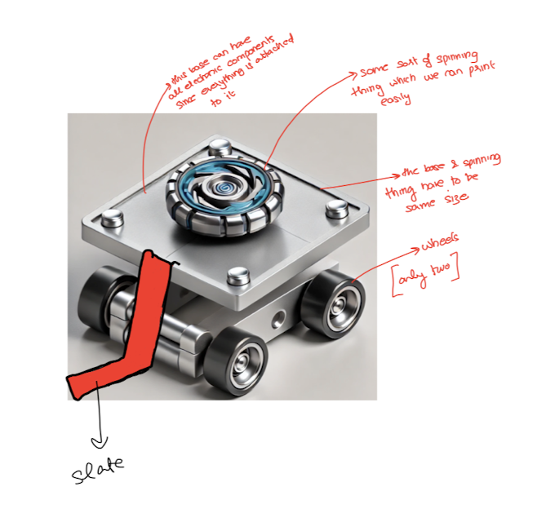

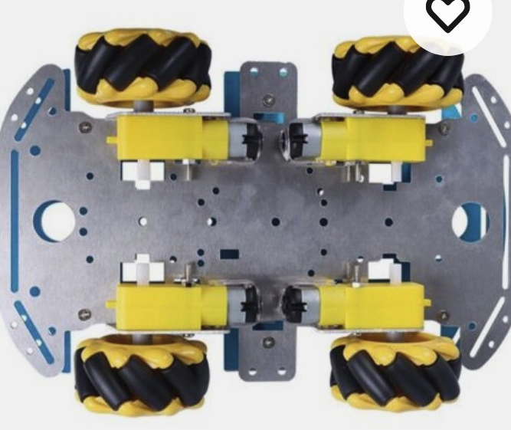

**WHEELS** (approx. 20 dollars needed for 4 wheels)

* Using Mecanum wheels -> 2 or 4 wheels
* 3 things needed:
  + motor (directly drives the movement of the wheels)
  + motor driver (between the microcontroller and the motor**)**
  + microcontroller (Sends signals to the motor driver, which then controls the motors based on PC input)
* Each wheel needs a motor
* Multiple motors can be controlled by the motor driver

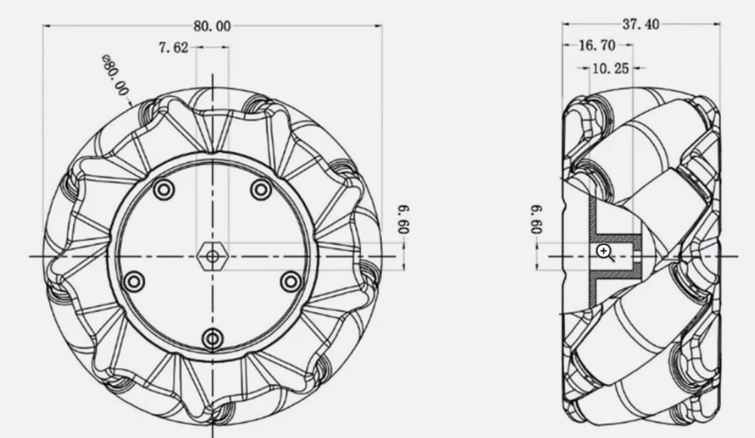

**MOTORS**

* We need motors for:
  + Wheels
  + Spinning the beyblade thingy
  + Flipping slate

| **Part** | **Motor** | **How Many** | **Motor Driver** | **Price** |
| --- | --- | --- | --- | --- |
| Wheels | N20 Micro gear motor | 2 or 4 | L298N (1 or 2) |  |
| Spinning thingy | Brushless DC motor | 1 | Electronic Speed Controller |  |
| Flipping slate | Servo Motor and Springs | 1 | No motor driver needed | Megha has |

**SLATE**

**MICROCONTROLLER**

**EQUIPMENT WE HAVE**

* **Uln2003 stepper motor driver**
* **Microservo 9g**
* **step motor 28BYJ-48 5V DC**

**USEFUL LINKS AND INFO**

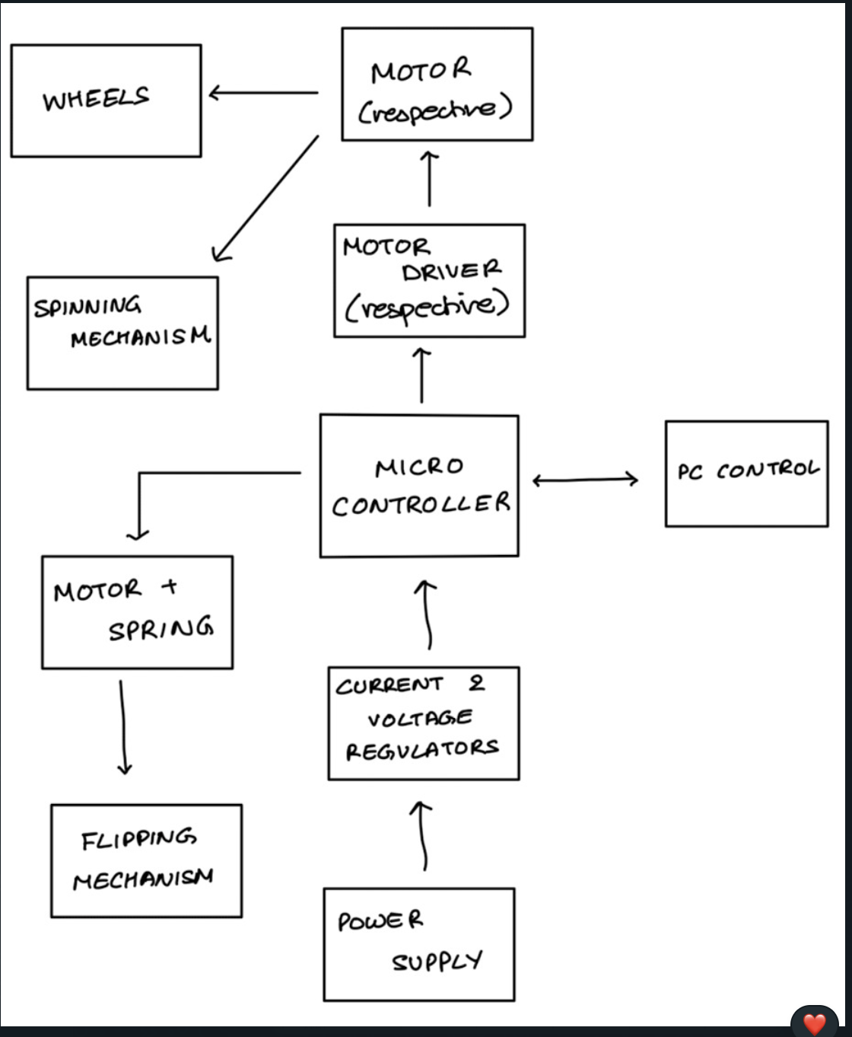

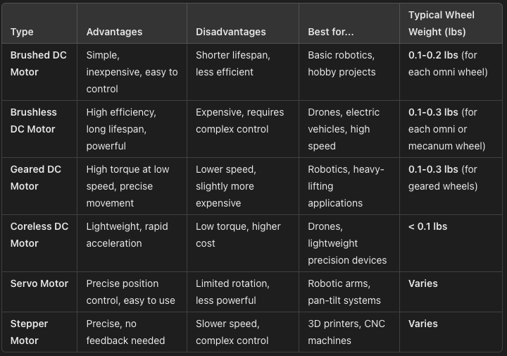

**WHERE TO BUY STUFF**

* <https://www.walmart.com/ip/Mecanum-Wheel-Smart-Robot-Car-Parts-Accessories-OmniDirectional-DIY-Toy-Components-48mm-1-Pair/10654567854?wmlspartner=wlpa&selectedSellerId=102516168>
* <https://www.amazon.com/JUZITAO-Motor-3V-6V-Gearbox-Motorfor/dp/B0CQ7WLZF9/ref=sr_1_6?dib=eyJ2IjoiMSJ9.xDSYQWV64jRZuTitsYuIoh5Ne45LEvKhJOZzAABS8P96TkjpnoPzTLA51kb3o4_m5I1S7GG3n9SPFAZSGSX3Nq04MUNblZSpDGSI7F5RX9pKqbT62ZtfQJuU3m9Va7NJ3DusmntxOi0qeSKu9whi9ElaGZl8rx7aMVEg96NiFNrmlyNSTxkWib-Iv3BooR9T9uEKDPKcCN_FKimEttDqIg2WXD4bXguyfg5pxbm3XFkvczsFxI8uT8nUcFKEPiXuE68MyBTdG_UNTFJRfrmuhtM6mZ74Z3nFnoR32iJ9PUs.uNamHgfGHBGsKVS9nc_1fGK2IZUNV1seQWJGYrFGkCU&dib_tag=se&keywords=n20+motor&qid=1726521688&sr=8-6>

# HIGH LEVEL REQUIREMENTS

1. The battle bot shall not exceed the weight limit of 2 lbs including all electrical and mechanical components
2. The battle bot shall be able to receive commands via WiFi and perform actions with minimal delay
3. The battle bot’s chassis shall only be made of the allowed plastic materials (PET, PETG, ABS, or PLA, PLA+)

**QUESTIONS**

* Do we need to 3D print the wheels?
* Is it okay to have the flipping mechanism?
* Is it okay to use omni wheels? Do you think we should be using something else?
* Do you think bot will be stable with 2 wheels? We want 4 but the weight might not allow it?
* Do we need a motor driver? Why?
* Is it okay to buy electrical components off of ebay?
* Would we be connecting wheels in series or parallel or both?
* What does the timeline for this project look like, by when should we aim to have all our parts delivered?